**Problem Statement:**

You work for XYZ Corporation. Your corporation wants to launch a new web-based application and they do not want their servers to be running all the time. It should also be managed by AWS. Implement suitable solutions.

**Tasks To Be Performed:**

1. Create a sample Python Lambda function.

2. Set the Lambda Trigger as SQS and send a message to test invocations.  
  
  
**create a s3 bucket**  
  
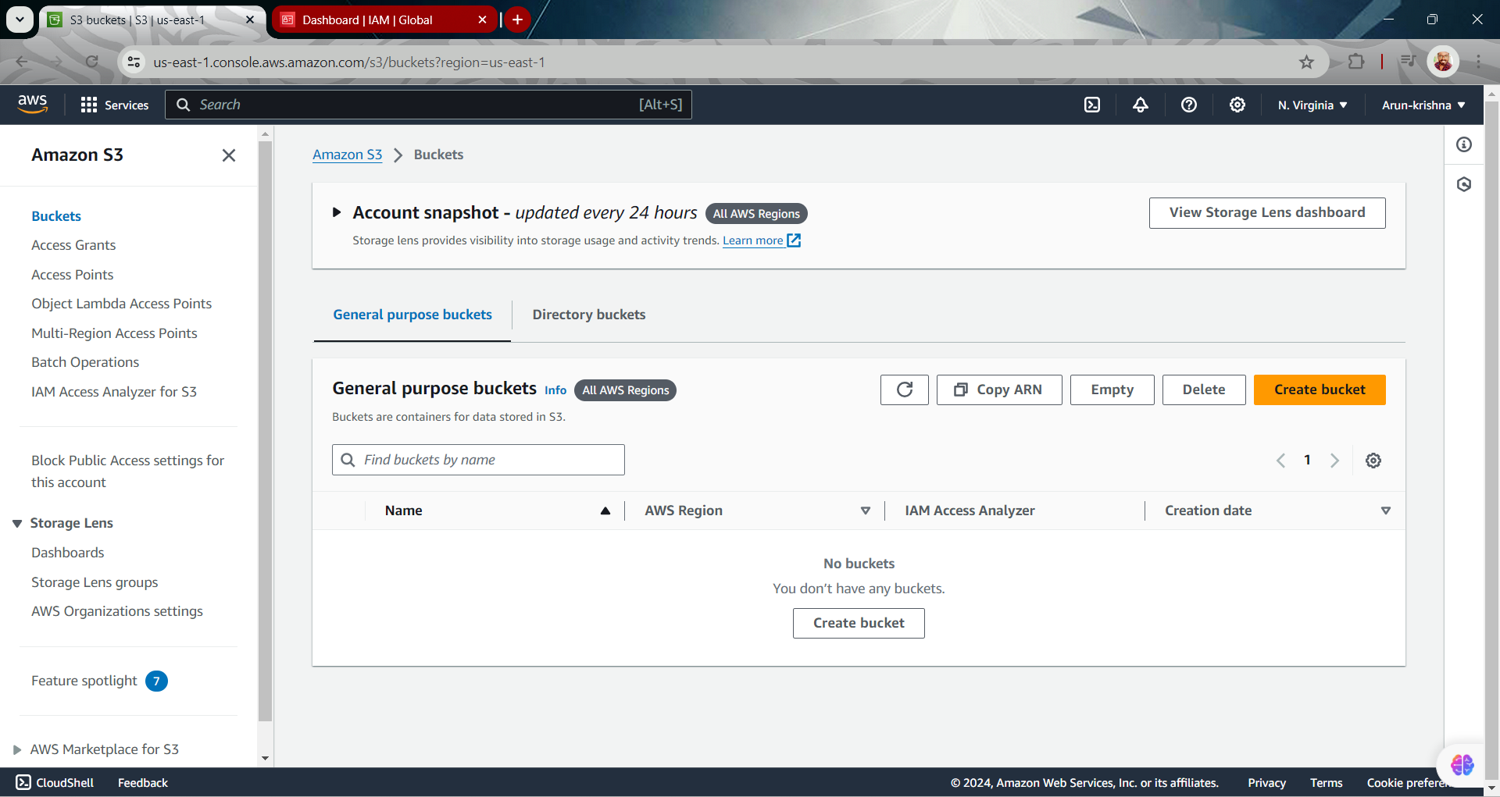  
  
  
  
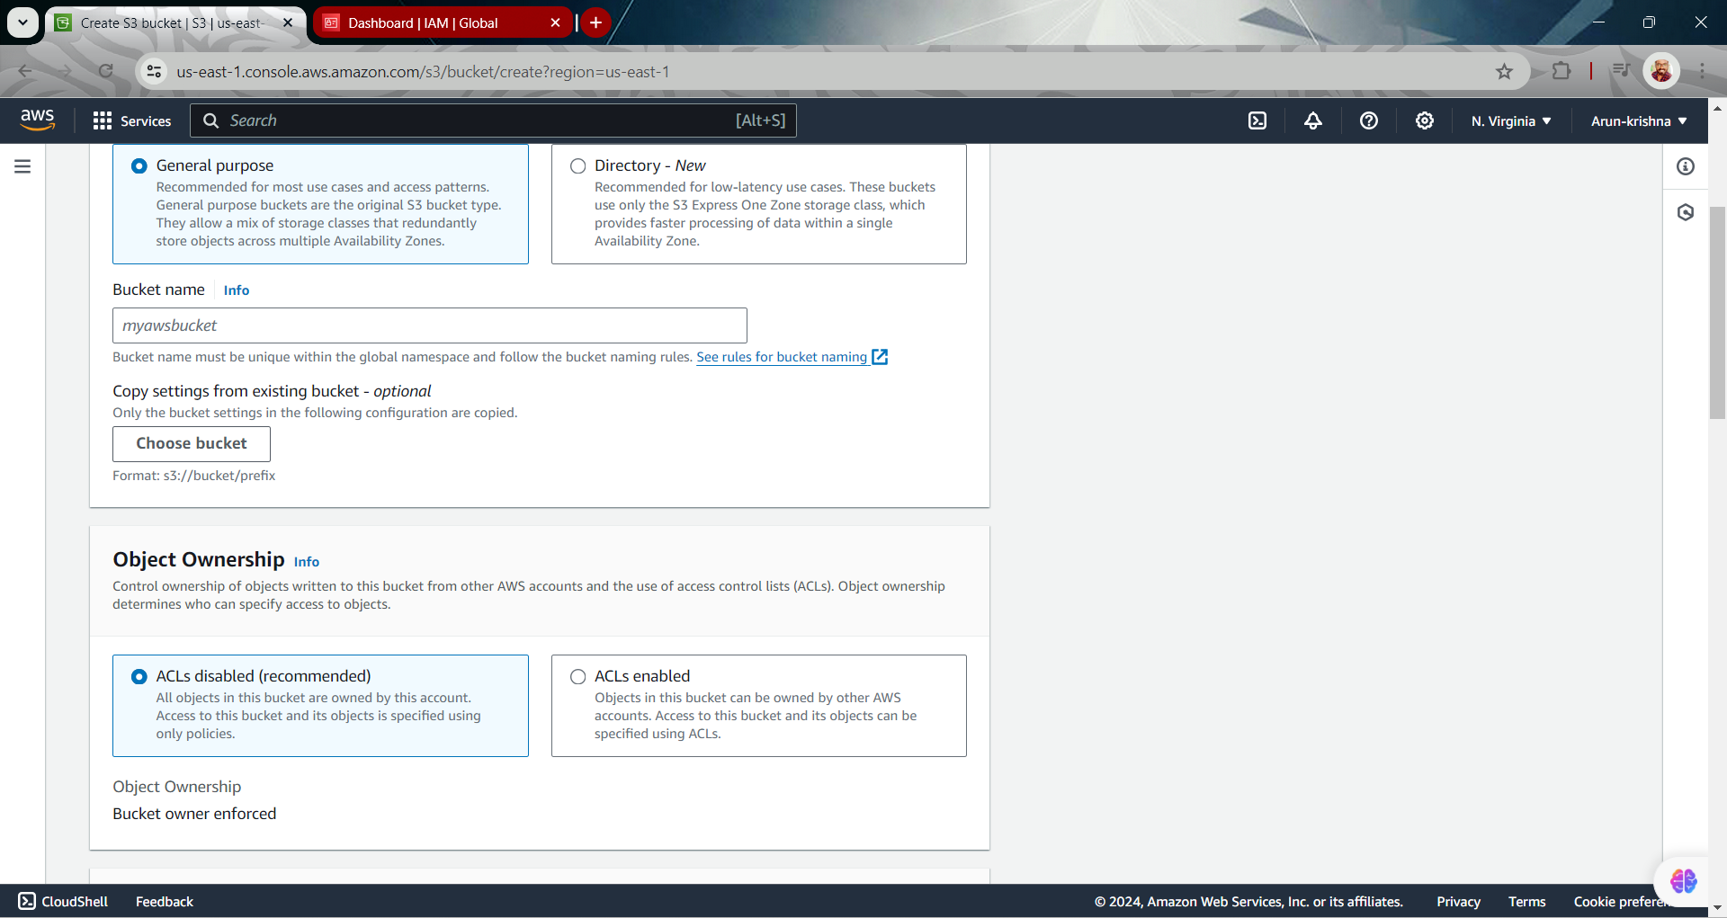  
  
  
  
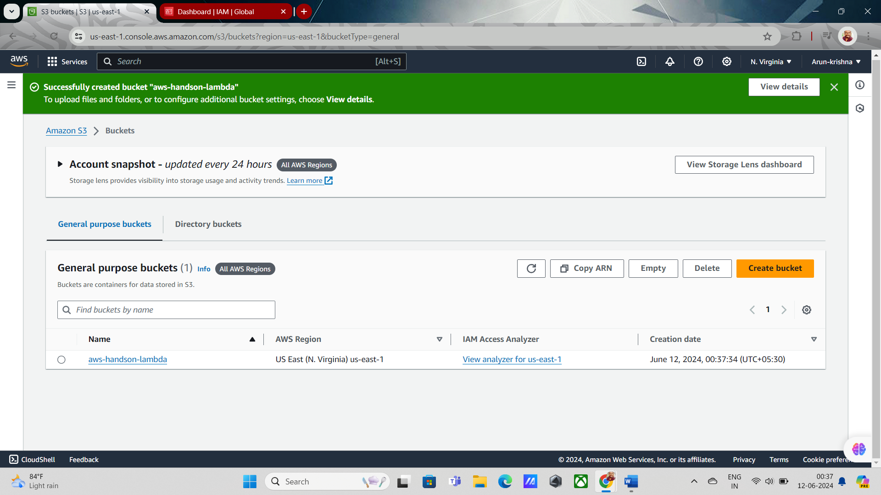  
  
  
  
 **create a lambda function  
  
  
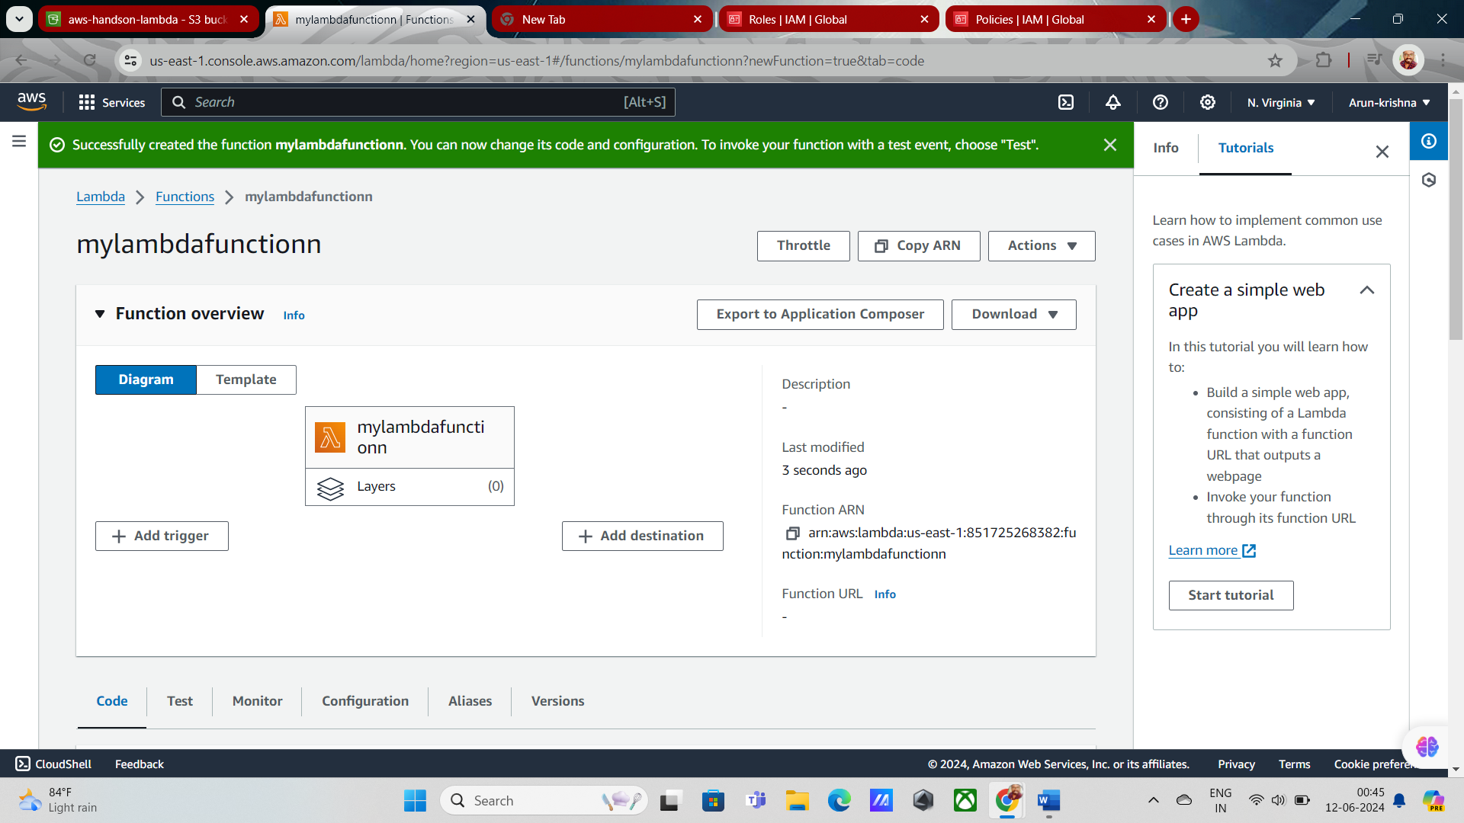  
  
  
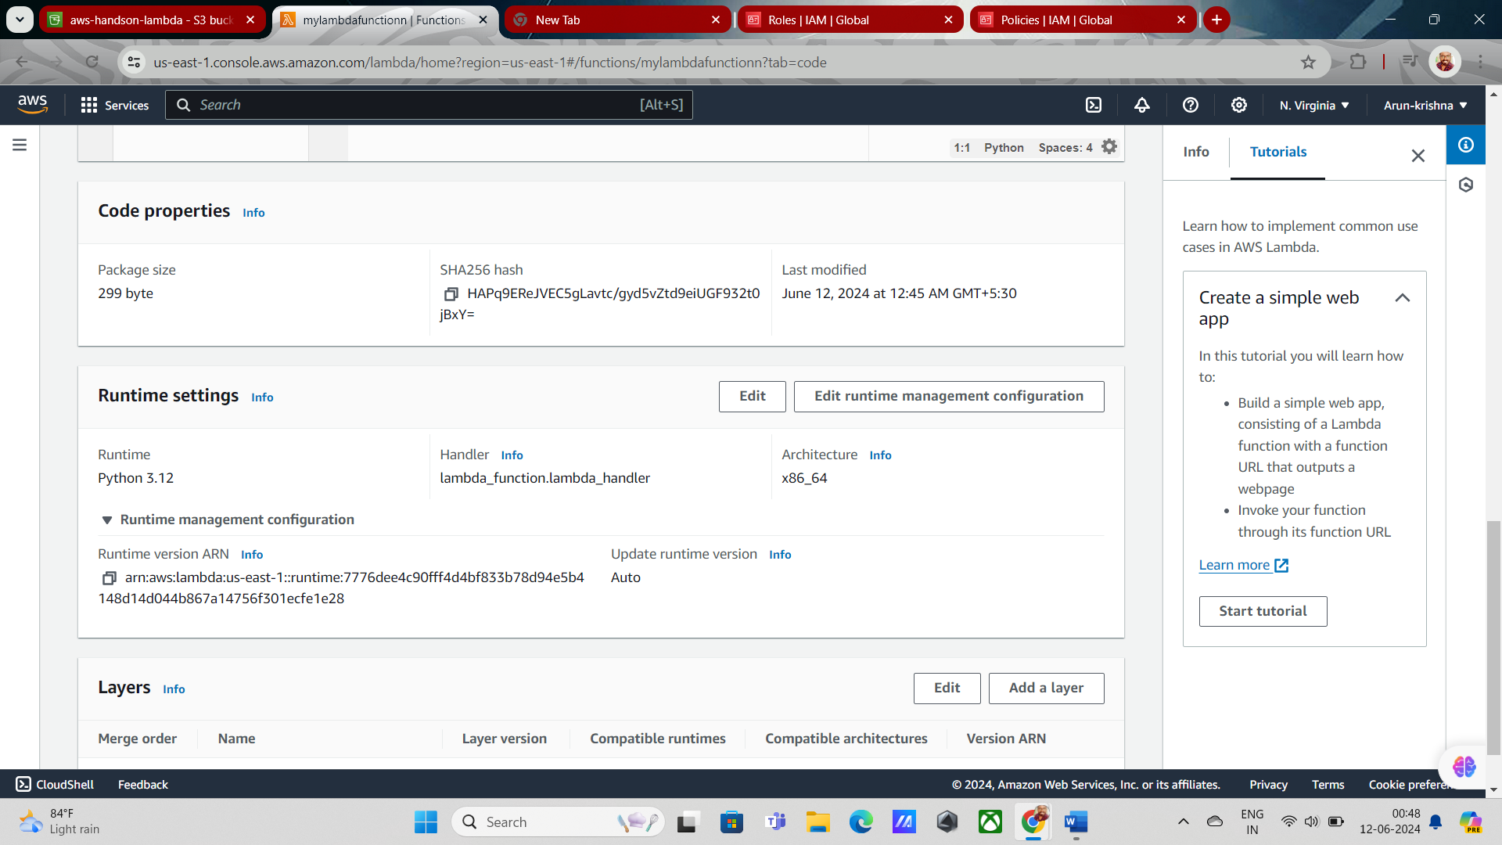  
  
  
  
  
next need to add trigger  
  
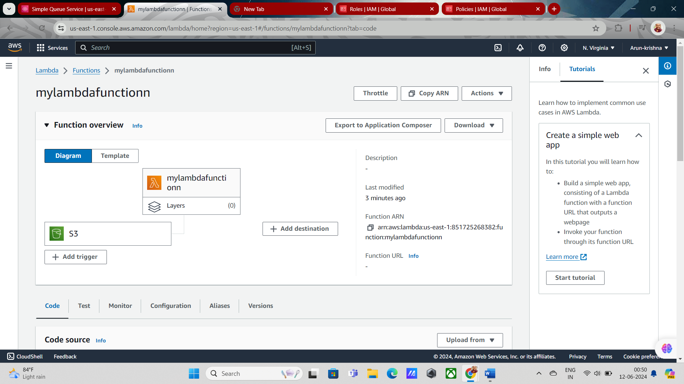  
  
  
  
next need to add destination in sqs   
  
need to create a sqs  
  
